ASSIGNMENT-2

GLOBAL SALES DATA ANALYTICS

Data Cleaning:(Before)

Data cleaning link:

https://us3.ca.analytics.ibm.com/bi/?perspective=ca-modeller&pathRef=.my_folders%2Fdata_cleaning_Tarun

Data Visualization:

Sales by customer

Data Visualization:

Sales By location

Data Visualization:

Sales by sales representative

Received Inventory from Supplier

Data Visualization:

Inventory stock for warehouse locations

Sales trend

Data Visualization:

Monthly Sales

Actual and Received Inventory by month

Tab 1

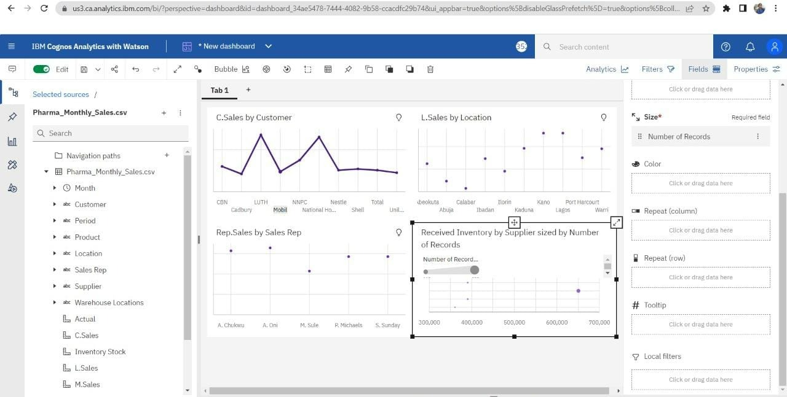

Tab 1 – link

<https://us3.ca.analytics.ibm.com/bi/?perspective=dashboard&pathRef=.my_folders%2Fdashboard_tab1_tarun&action=view&mode=dashboard&subView=model0000018384e948b1_00000000>

Tab 2

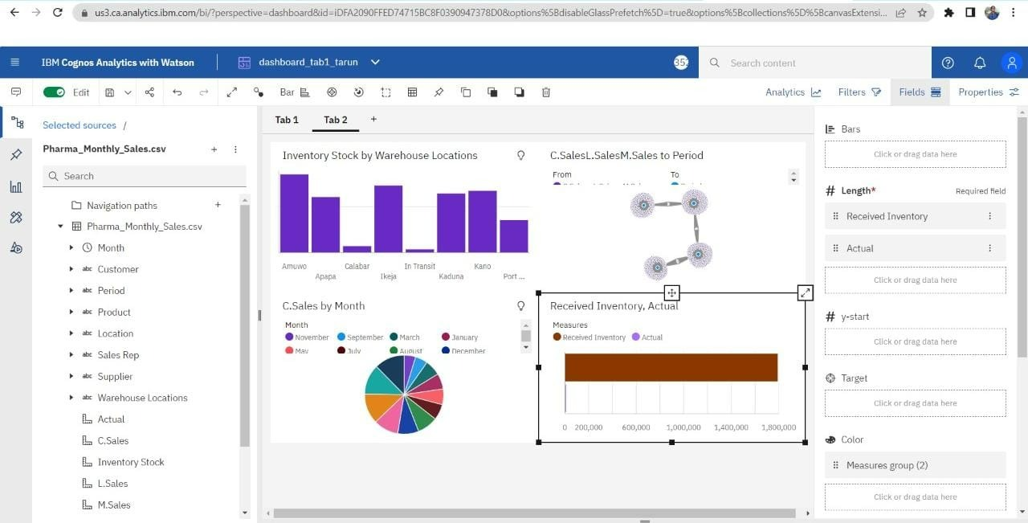

Tab 2 – link

<https://us3.ca.analytics.ibm.com/bi/?perspective=dashboard&pathRef=.my_folders%2Fdashboard_tab1_tarun&action=view&mode=dashboard&subView=model0000018384f92598_00000000>